**Business Requirements Document**

**End Customers Portal Features:**

* User-friendly product search and filtering options.
* Detailed product descriptions, images and reviews.
* Shopping cart and checkout process.
* Secure payment gateway integration.
* Order tracking and delivery status updates.
* Personalized recommendations based on browsing history.
* Customer support and contact options.

**Vendor Portal Features:**

* Vendor registration.
* Product management interface for adding, editing, and removing products.
* Inventory management tools.
* Pricing and discount management capabilities.
* Order management dashboard.
* Analytics and reporting dashboard.
* Communication channels with customers.
* Vendor support and assistance.
* Integration with shipping and logistics services (If client needs).

**User Journey - Customer Onboarding:**

* Landing on the homepage.
* Browsing or searching for products.
* Viewing product details and reviews.
* Adding products to the cart or wishlist.
* Proceeding to checkout.
* Providing shipping and payment information.
* Confirmation of the order.
* Post-purchase support and feedback.

**Flow Chart for Customer Journey:**

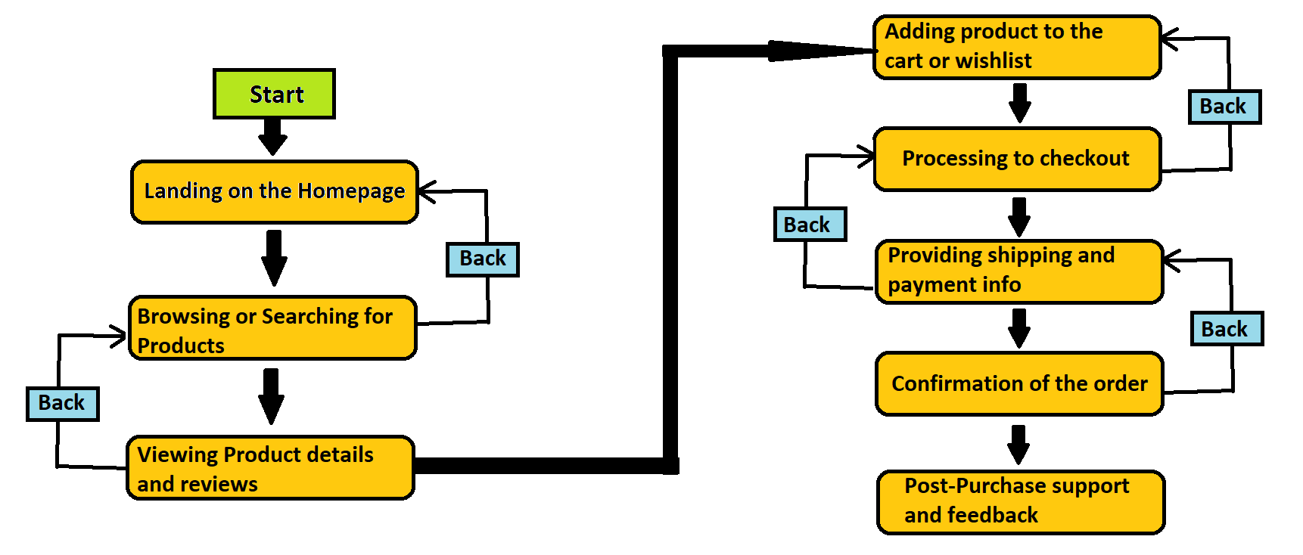

**User Journey - Vendor Onboarding:**

* Landing on the vendor registration page.
* Filling out necessary details for registration.
* Verification of identity and business information.
* Setting up vendor profile and product listings.
* Configuring payment and shipping settings.
* Accessing analytics and reporting dashboard.
* Managing orders and inventory.
* Interacting with customers and addressing queries.

**Flowchart for Vendor Journey:**

